Ahmad Barakat
IT286
Carol Tilden
06/16/2026
Importance of Risk Assessment
A risk assessment is done in order to identify potential hazards and analyze what could happen when a disaster or incident occurs. There are many risks to consider, and it could cause endless possibilities of attacks. In this case, the case of a risk assessment is to evaluate what would prove the most harmful to an organization and how to take action on the assessment. Here are five things we can do after completing a risk assessment:
- Identify & Document - List every potential risk, internal, external. This ensures no significant threat is overlooked
- Analyze - Examine each risk in detail, nature, scope, and potential impact. How and where it could impact an organization and potential consequences.
- Evaluate - Assess every analyzed risk and determine the priority level, based on likelihood and impact level, and then combine to prioritize from highest to lowest concerns.
- Treat - Make a decision on implementation of appropriate response for each significant risk. Develop action plans to mitigate risks, avoid risks, transfer them, or accept them if the risk appetite allows.
- Monitor - Not all risk can be mitigated, track identified risks and review the effectiveness of risk management measures. Some risk will always be present, monitoring is what can be done by thorough employees for that little bit of risk that may remain dangerous to an organization (Vincente).
Planning for risks helps identify the potential for them before they occur so an organization is ready when it happens. Staying on task allows for mitigation activities like security controls and audits are completed consistently and correctly. Meeting deadlines reduces vulnerabilities and helps maintain compliance requirements. Utilizing feedback lets the organization correct weaknesses, and have stronger risk management over time.
After reviewing the Purdue website’s security policy, they approach their post risk assessment procedures similarly:
Notice - Telling their users what they’re collecting before they collect it, showing transparency with the users.
Choice - They’re letting the users opt in or out of data collection and use. This way users can’t really report anything and create legal issues when they are given the choice.
Access - Allowing users to see, edit, or delete their data as desired.
Security - To protect data and disclose how they’re going about protecting it.
Enforcement - Showing how the policy is enforced
For Key personnel, we will be assigning a few important roles within our security team:
Risk Manager - Manage organizational risks by identifying them, analyzing them, and reporting risks to the CISO.
IT/Security Teams - Security controls, system monitoring, and incident response.
Employees and End Users - Follow security policies, report incidents, and help reduce human related risks
Compliance Team - Make sure that the organization follows laws, regulations and industry standards.
These personnel will be promoted through their previous contributions or recruited into the organization based on their experience, determination to protect from threats and show accountability with their previous work. It is also important that everyone on the team gets tasks done in a timely manner and have experience working in a group setting. These factors reduce potential losses, and increase the likelihood of successful risk management results.

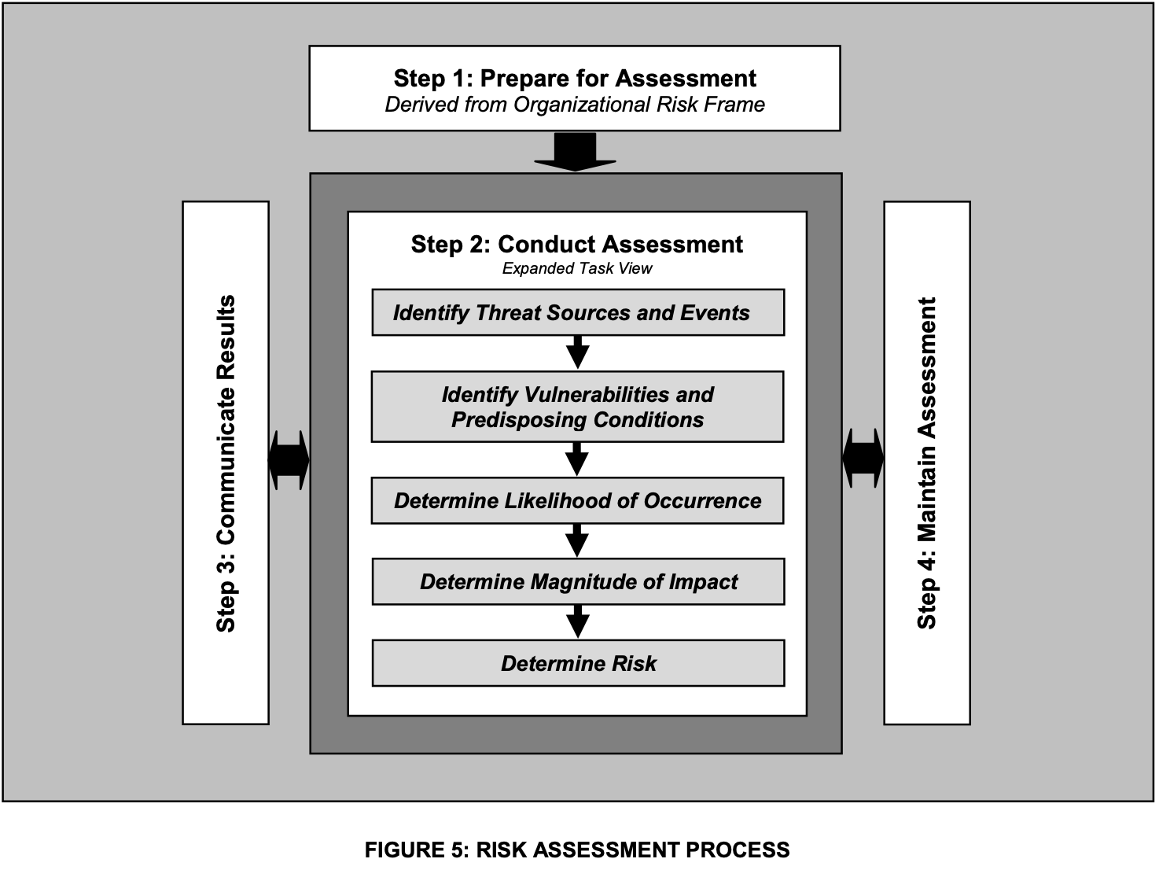
In the NIST Publication, a threat is a circumstance or an event that has the potential to adversely impact an organization, its assets, individuals through unauthorized access, distruction, modification of information, or denial of service. A vulnerability is considered a weakness in an information system, security procedures, internal controls, or implementation that could be exploited (NIST 800-30).

References
- National Institute of Standards and Technology. (2012, September). Guide for conducting risk assessments. NIST Special Publication 800-30. U.S. Department of Commerce. http://nvlpubs.nist.gov/nistpubs/Legacy/SP/nistspecialpublication800-30r1.pdf
- Vicente, V. (2026, March). 10 types of risk management strategies to follow. https://optro.ai/blog/10-risk-management-strategies

